5 Simple yet Delicious Greek Recipes to Try this Weekend

Greece may be known for its idyllic beaches, ancient ruins and passionate culture, but the country’s wonderfully fragrant and indulgent food is high on the list, too.
Want to re-create memories of your favourite Greek getaway? You can replicate the delicious traditional dishes of a Greek tavern without travelling beyond your local supermarket. Grab yourself a glass of ouzo (or wine, if aniseed isn’t your thing) and check out these five tasty but easy-to-prepare Greek dishes. Now, where’s that sunshine?

Beef Stifado
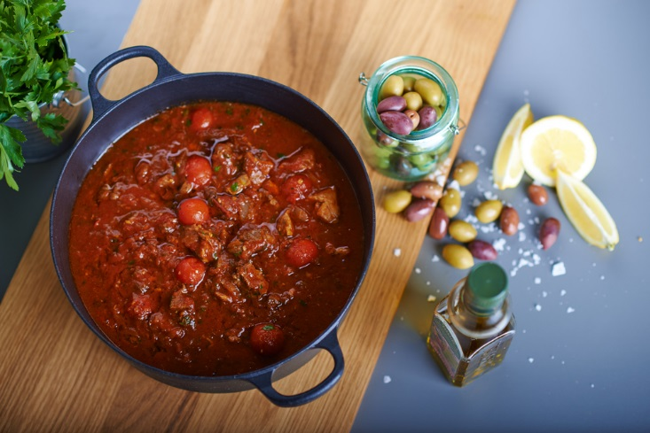
jmattisson / shutterstock.com
Stifado, a traditional Greek casserole, is an unbeatable dish if you’re wanting something hearty and filling, yet fresh. The slow cooking makes the beef deliciously tender and melt-in-your-mouth and the onion and red wine-based sauce is unbelievably rich and aromatic. This is a firm favourite in every Greek family – often served with orzo (tiny rice-shaped grains of pasta). See the recipe here.

Kleftiko

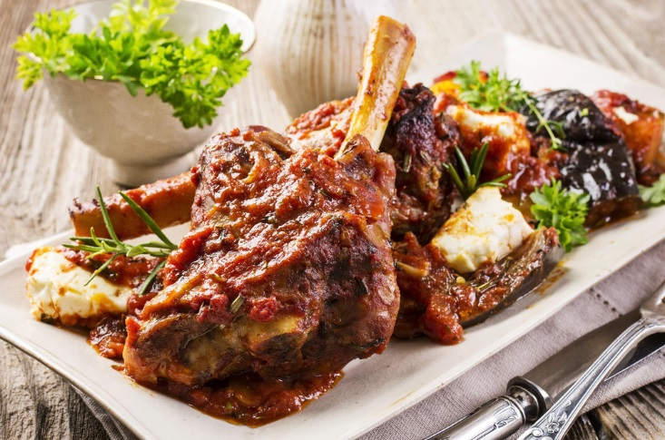
HLPhoto / Shutterstock.com
Slow cooked lamb that falls off the bone, with soft, fluffy and flavoursome potatoes, and all cooked in a delicious white wine and herb sauce. This all makes kleftiko the perfect meal choice if you fancy something easy but delicious. This hearty and delicious Greek classic is sure to become a favourite in every household – and don’t forget the flatbread to mop up the sauce!
You can try this recipe for yourself here.

Chicken Souvlaki
Source: Ania Mendrek
Sometimes, simple is better. Souvlaki – or souvlakia, if you (inevitably) have more than one – is a Greek kebab consisting of grilled meat and vegetables, usually served with pita and a dip like tzatziki.
This dish is great for the whole family, and ideal for a dinner party with a difference. Better yet, it’s comfort food without the guilt, as souvlaki is delicious and filling but fresh and nutritious, too. Mmm!
Have a go at Yvonne’s recipe here.

Greek salad with Lemon Garlic Dressing

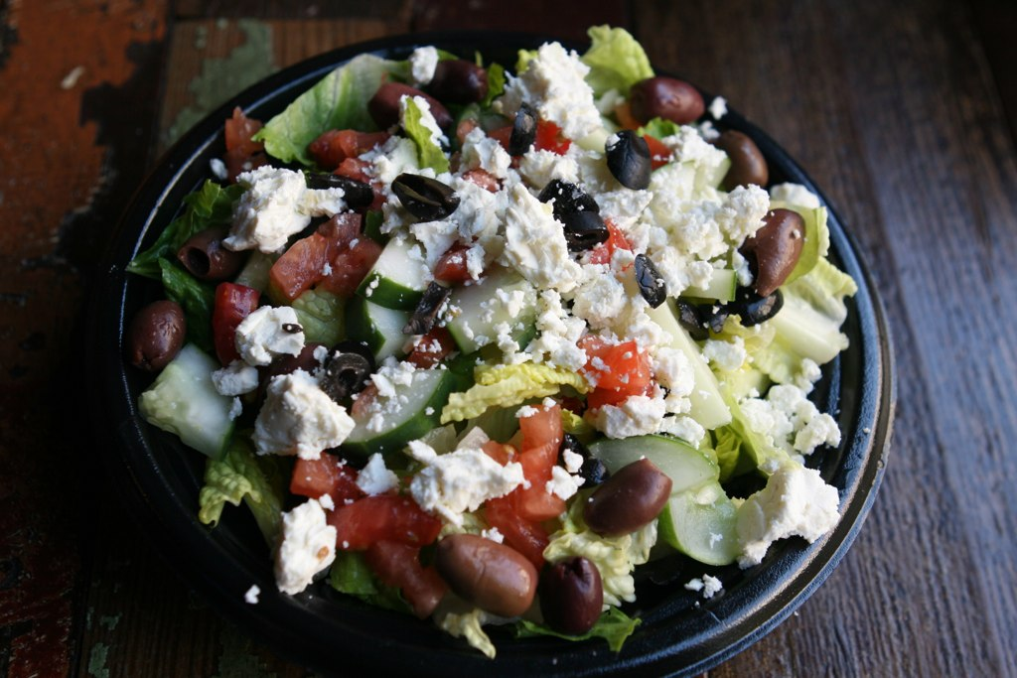
Source: Susan Lucas Hoffman
No Greek recipe roundup would be complete without a recipe for a simple Greek salad, and this one doesn’t disappoint. The key to a great Greek salad is fresh ingredients and a good dressing, and this recipe’s blend is spot-on. This is a wonderful dish for summer, whether served on its own or as an accompaniment to any one of these delicious Greek recipes.
Stephanie’s recipe is finished with a lemon and garlic dressing for a tangy twist on the classic.

Greek Mezze: Marinated Feta, Homemade Hummus & Baba Ganoush
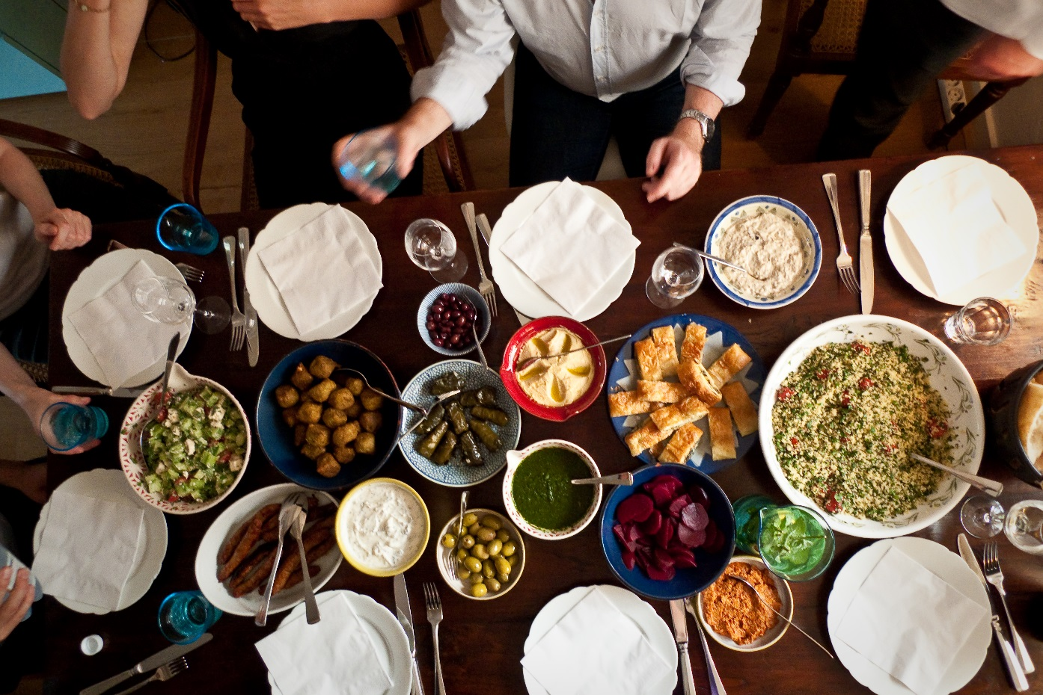Source: Stijn Nieuwendijk
This is actually a few recipes in one, but don’t let that put you off - mezze will wow your friends and family without taking up too much of your time. It’s an indisputable fact that homemade hummus is better than its shop-bought counterpart, and these recipes for marinated feta and baba ganoush are a simple yet impressive addition to any get together or summer garden party. Serve with pita, olives and chopped vegetables for dipping and you’re good to go!

